<Offer Calculator>
<Bids and offers>

Table of Contents
1. Overview 3
2. Components in Execute Offer Strategy 3
A. Ribbon Menu 4
i. Export 4
ii. Query Inputs 4
iii. Actions 5
iv. Layout Manager 5
v. Favorite 5
B. Offer Strategy Run History Table 6
3. Actions to perform in Execute Power Strategy 7
A. Executing Strategy 7
B. Exporting Offer Strategy Run History 8
C. Customizing the Layout 10

Overview
The Offer Calculator screen enables you to perform backend offer calculations by specifying inputs such as date, ISO, participant, asset, and strategy. It triggers a stored procedure that processes steps such as data retrieval and pricing logic. You can monitor execution in real time via logs showing status, info, or error messages. You can use the logs for analysis and raise support tickets for the errors that occurred during execution.
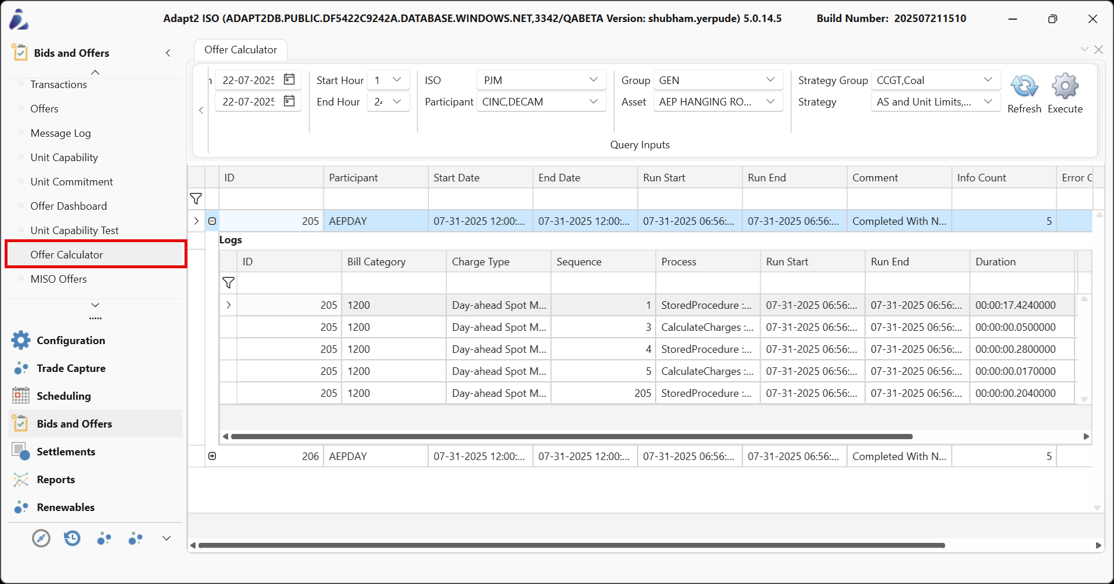

Components in the Offer Calculator
The Offer Calculator screen includes a ribbon menu for entering run parameters, an offer run table for viewing execution details, and a logs window for step-by-step processing insights. Together, these components support the execution, validation, and troubleshooting of generation offer strategies.
- Ribbon Menu
- Offer Run Table
- Logs Table

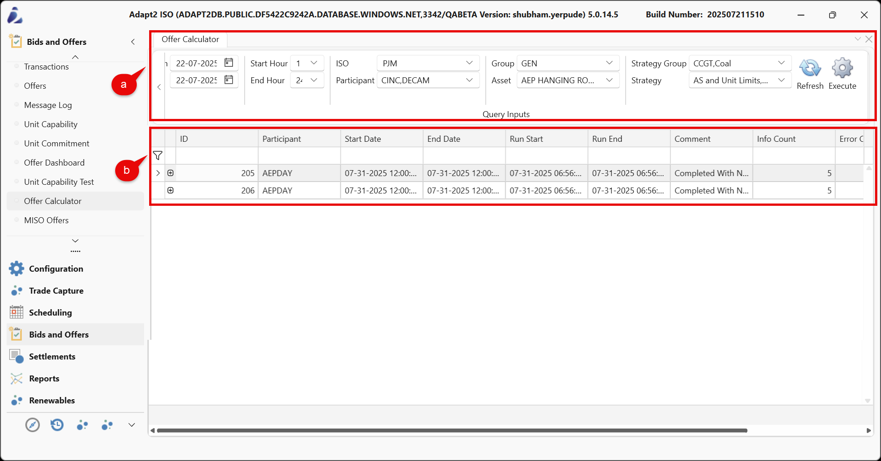

Ribbon Menu
The Ribbon Menu in the Offer Calculator screen allows you to configure key inputs such as date, hour, ISO, participant, group, asset, strategy group, and strategy. It includes Refresh to validate inputs and execute to trigger backend offer calculations via stored procedures. The ribbon is the main control panel for efficiently setting up and running offer processes.
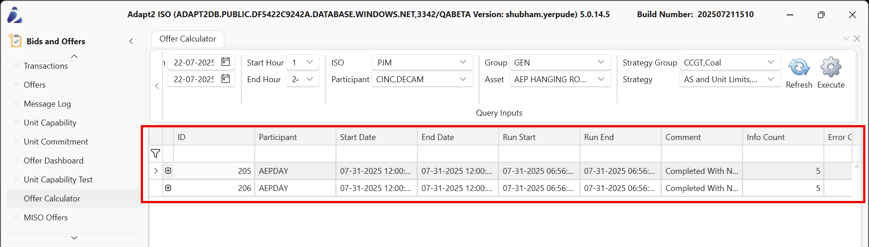

Refer to the following specifications for group functionalities in the Ribbon Menu.
Buttons | Description
From/To | Defines the start and end dates for the offer strategy execution window.
Start Hour / End Hour | Specifies the hourly range (within the selected date range) to constrain the calculation period.
ISO | Selects the target ISO market in which the offer will be submitted.
Participant | Identifies the market participant or bidding entity.  NOTE: Options are dynamically updated based on the selected ISO.
Group | Designates the asset group to be used for the selected strategy.
Assets | Displays the individual assets associated with the selected group.
Strategy Group | Filters the available offer strategies by logical or operational categories.
Strategy | Selects the specific strategy logic to apply during offer calculation.
Refresh | Reloads the page based on the configured selections and updates dependent dropdowns.
Execute
  Initiates the offer strategy run using the configured parameters and strategy logic.

Offer Run Table
The Offer Run History section provides a comprehensive log of executed offer strategies. Each row captures critical metadata such as Run ID, Participant, Date range, execution timestamps, and result summary (e.g., success or error status). You can monitor and briefly verify each offer run's outcome.
Expanding a run displays detailed log entries showing the Bill Category, Charge Type, Sequence of operations, system process used (e.g., stored procedures), and precise run durations. This enables you to trace the execution path, identify bottlenecks, and diagnose calculation issues efficiently.
This table is essential for validating offer strategy execution, troubleshooting errors, and auditing market interactions across ISO environments.

Offer Run History Table
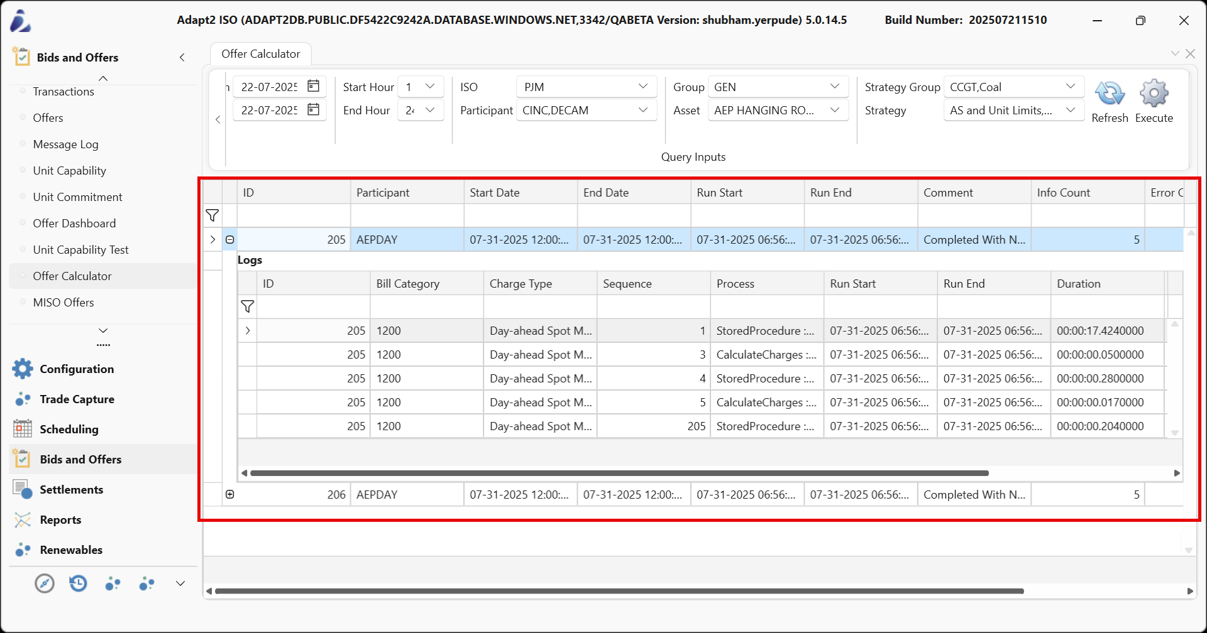
Below is a detailed explanation of each column.
Buttons | Description
ID | Specifies the Unique identifier for each offer run entry.
Participants
  Displays the market participant or bidding entity associated with the run.
Start Date
  Defines the beginning of the offer calculation window.
End Date | Specifies the end of the offer calculation window.
Run Start | Captures the timestamp when the offer calculation process begins.
Run End | Captures the timestamp when the offer calculation process completes.
Comments | Summarizes the execution result or system status message.
Info Count
  Indicates the number of informational messages generated during the run.
Error Count
  Indicates the number of errors encountered during the offer calculation run.
User
  Displays the name of the user who initiated the offer calculation run.

Offer Run History Logs Sub-Table

Field | Description
ID | Link the log entry to its corresponding offer strategy run.
Bill Category | Represent the billing category processed (e.g., DA Spot Market).
Charge Type | Specify the type of market charge processed.
Sequence | Define the execution order of each calculation step.
Process | Identify the internal process executed (e.g., stored procedure, calculation).
Run Start | Record when the individual process began.
Run End | Record when the individual process completed.
Duration | Measure the elapsed time for the specific process execution.

Logs Table
The Logs Table displays detailed, step-by-step execution records for each offer run. It captures essential information, such as Run ID, Strategy, Strategy Group, Asset, Sequence, Process Step, Start and End Time, Log Level (e.g., Info or Error), and Comments describing each step's outcome. This table helps you to trace the full execution flow, identify where issues occurred, and understand the logic applied during each calculation stage. It serves as a diagnostic tool for reviewing and troubleshooting offer run processes.

Buttons | Description
ID | Identifies the unique ID for the log entry.
Run Id | References the ID that links the log entry to a specific offer run.
Strategy | Indicates the strategy used during the offer calculation step.
Strategy Group | Group strategies by type or purpose for organizational reference.
Asset | Displays the name of the asset associated with the log entry.
Sequence | Shows the step number representing the execution order within the run.
Process | Displays the name of the process being executed.
Run Start
  Indicates the timestamp when the log process began execution.
Run End
  Indicates the timestamp when the log process completed execution.
Log Level | Indicates the severity or type of log message.
Comment | Provides a detailed message related to the process execution or error.

Actions to Perform in the Offer Calculator
The Offer Calculator provides an intuitive interface for configuring and executing offer strategies by interacting with backend calculation services. You can review detailed logs to understand the execution flow, identify errors, and rerun processes if needed. This functionality supports accurate and transparent offer creation for market submissions.
- Executing Strategy
- Error Handling in Offer Calculator

Executing Strategy
Executing a strategy involves selecting predefined input parameters and initiating a backend process that performs the strategy-specific calculations. The Offer Calculator screen is located under the Bids & Offers module.
To execute an offer strategy:
- In the Offer Calculator screen, within the Query Inputs section of the ribbon menu, configure the required fields.
- From / To Date: Select the start and end dates for the offer calculation period.
- Start Hour / End Hour: Choose the hour range within the selected dates to define the run window.
- ISO: Select the relevant ISO for the offer run (for example, AESO, MISO, PJM).
- Participant: Select the market participant responsible for executing the offer.
- Strategy: Select the predefined offer strategy to be applied.
- Group: Select the asset group.
- Asset: Choose the specific asset to execute the strategy on.
- Strategy Group: Select the group category that contains the applicable strategies.
- Strategy: Choose the specific offer strategy to be executed.
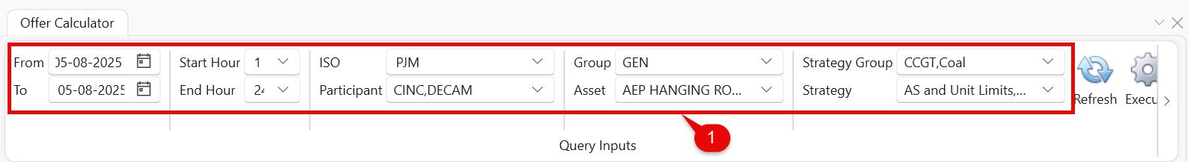
- Click Refresh (Optional) to update the dropdown fields and reload associated data.
- NOTE: It is recommended to refresh after modifying any dropdown selection. This ensures the interface reflects the most current values and helps prevent execution with outdated or mismatched input parameters.
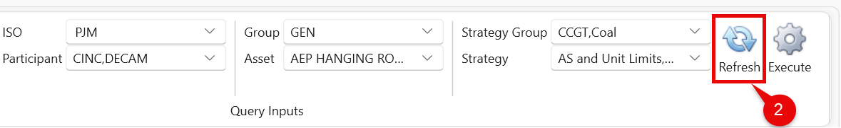
- Click Execute to trigger the offer calculation process.
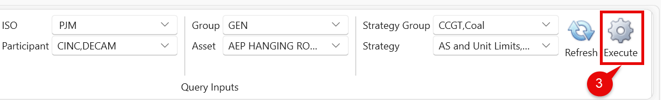
- When execution starts, a log window shows a step-by-step view of the process. Once the execution is completed, you can see the execution status as shown in the figure below.
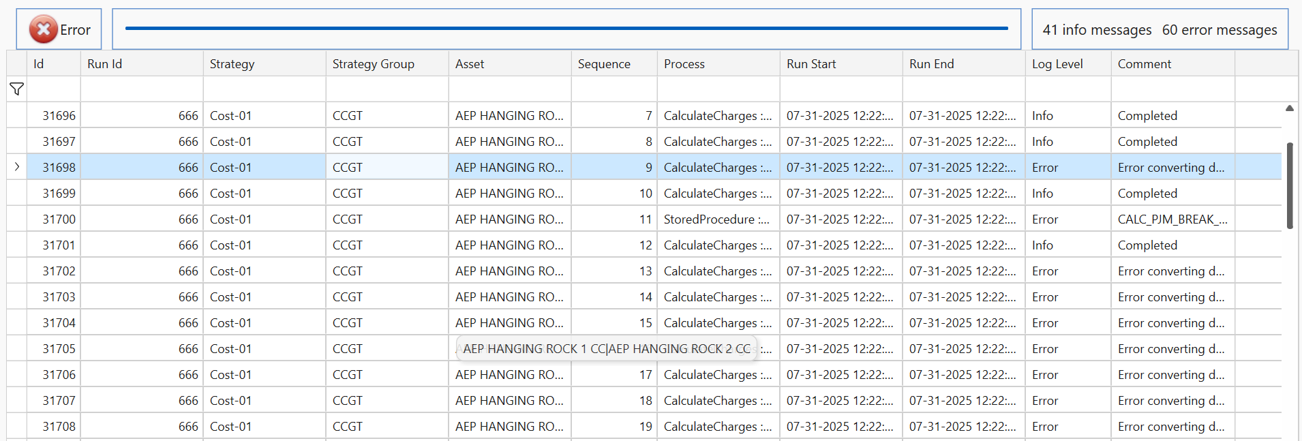
- After the run completes, close the log window to return to the main Offer Calculator screen.
- Select Refresh again to view the completed run in the Offer Run History table.
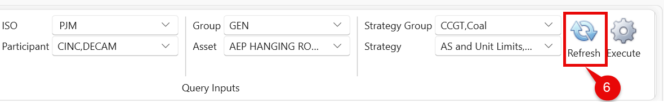
- Click Expand icon (+) next to the run ID to open its logs directly beneath the row.
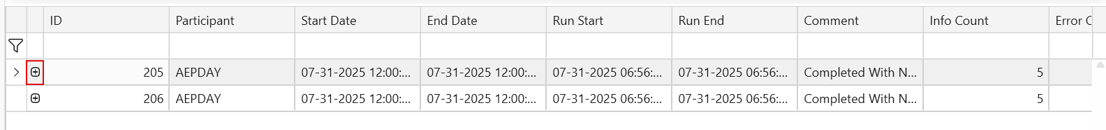
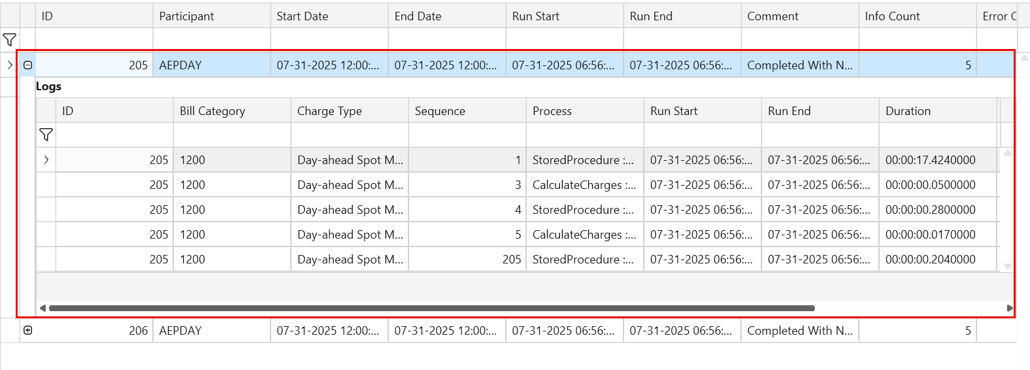

Error Handling in Offer Calculator Screen
System-generated errors may occur during the offer calculation process. After executing a strategy, these errors are captured and displayed in the Logs pop-up window.
Follow the steps below to resolve these errors.
- Go to the Comment column in the corresponding row to view the detailed error description.
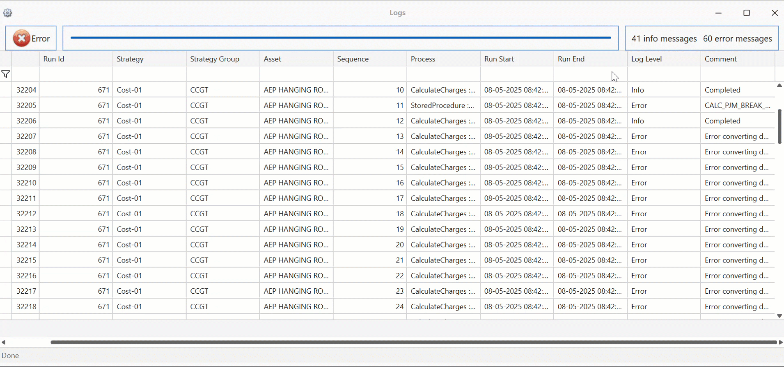
- Raise a support ticket that includes the detailed log message.
- Return to the Offer Calculator screen after the issue is resolved.
- Re-enter the required parameters and click Execute to rerun the strategy.

